
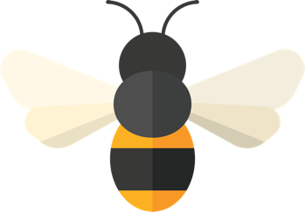

Pollinator Journal

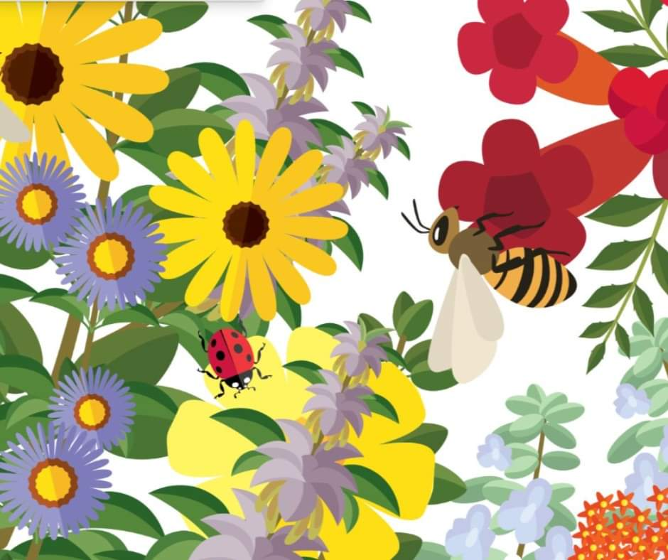

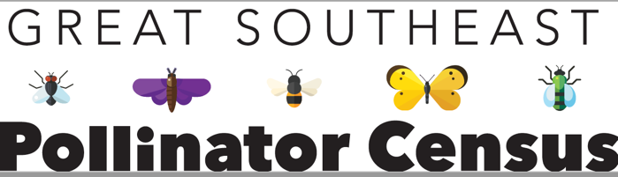
Inspiration:
Insects often visit flowers because of the flower color or form. Focus on one flower in the garden. Draw it with as much detail as possible. Did any insects visit your flower while you were drawing? What were they? If not, what type of insect do you think would visit your flower?

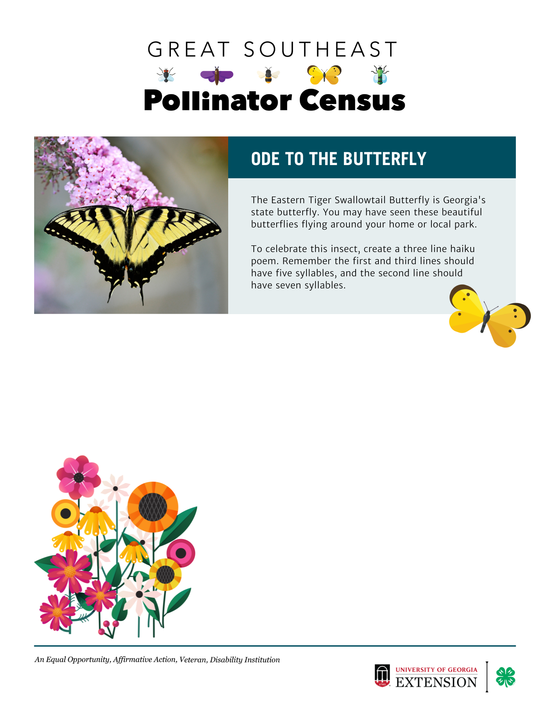

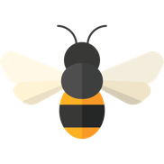
Inspiration:
Bumble bees are special pollinators. Their hairy bodies are perfect for attracting and moving pollen. Look for bumble bees in your garden. Watch them fly. Their flight patterns are fun to watch. See if you can capture their fun in a bumble bee drawing.

Inspiration:
Gardens can evoke feelings. Some gardens make us feel calm; some make us feel joyful. A formal garden may make us sit up a bit straighter. A vegetable garden may make us feel hungry! Find a comfortable area in your garden to sit. Create a word cloud using words that describe how your garden makes you feel.

Inspiration:
Concentrate your focus on one insect in the garden and work through this sheet:
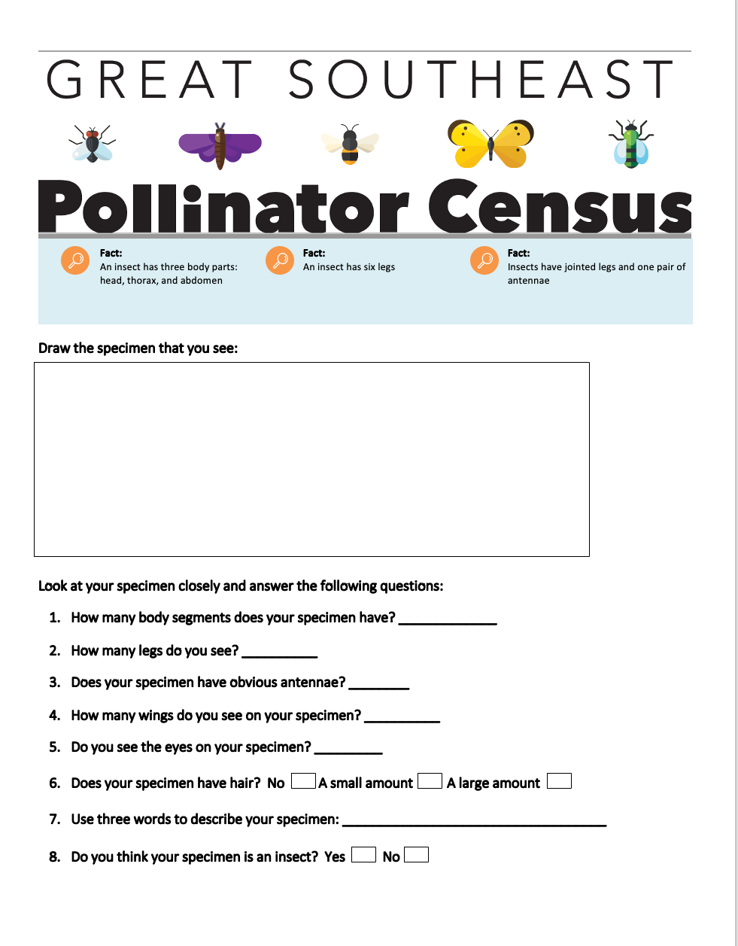

Inspiration:
Weather is a big influence in the pollinator garden. Weather patterns often move in through the jet stream. Thunderstorms can pop up during a warm afternoon. What weather are you seeing today? Lay on your back to get a view of the cloud patterns over your garden. Draw them.

Inspiration:
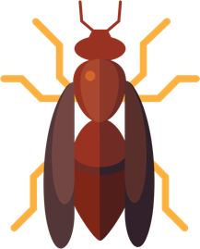
Wasps have a reputation for being mean and aggressive when they really provide positive benefits to our garden. They generally don’t sting unless they are threatened. They are efficient hunters of caterpillars and grasshoppers. See if you can locate a wasp in your garden. Can you see how its exoskeleton looks like plated armor? Draw your wasp visitor.

Inspiration:
An effective pollinator garden has flowers of all shapes, sizes, and colors. This diversity of plants attracts a diversity of insects. Draw a section of your garden that contains several different plant species.

Inspiration:
The Great Southeast Pollinator Census (https://GSePC.org) takes place each August and is a way for us to capture a snapshot of our pollinator populations. Do a practice Census count using one flower in your pollinator garden. Count the insects you see during a 15-minute period. You may want to repeat this using another type of flower and compare your results.

Pollinating Insect: | Number Counted:
Carpenter Bees
Bumble Bees
Small Bees
Wasps
Flies
Butterflies
Other Insects
TOTAL COUNTED

