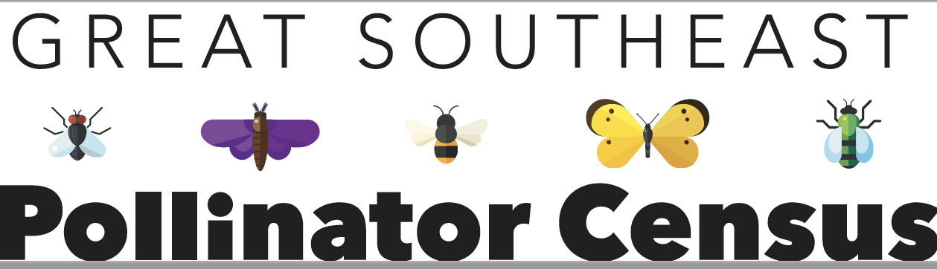
 | Fact:  An insect has three body parts: head, thorax, and abdomen |  | Fact:  An insect has six legs |  | Fact:  Insects have jointed legs and one pair of antennae

Draw the specimen that you see:

Look at your specimen closely and answer the following questions:

How many body segments does your specimen have? _____________

How many legs do you see? __________

Does your specimen have obvious antennae? ________

How many wings do you see on your specimen? __________
- Do you see the eyes on your specimen? _________

- Does your specimen have hair? No A small amount A large amount

- Use three words to describe your specimen: ___________________________________

- Do you think your specimen is an insect? Yes No

If you answered “Yes” to number 8, which category of insect do you think you see:
_____Carpenter Bee
_____Bumble Bee
_____Honey Bee
_____Small Bee
_____Wasp
_____Fly
_____Butterfly/Moth
_____Other Insect

Draw a picture of the place where you found your specimen:

This worksheet inspired by Project WILD.

